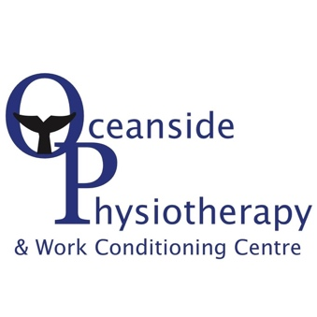
Licensed Physiotherapist

Company: Oceanside Physiotherapy & Work Conditioning Centre
Location: Parksville BC, Canada

Oceanside Physiotherapy & Work Conditioning Centre is located in Parksville, on the beautiful West Coast of Vancouver Island. Our clinic has been well established for 25 years and continues to grow. We pride ourselves on our family-like culture and atmosphere.

Key Responsibilites:
- Meeting with patients to assess what their physical challenges are and deciding on suitable treatment programs
- Monitoring the progress of patients and adjusting or changing treatments as needed
- Liaising with other healthcare professionals, such as Occupational Therapists and General Practitioners and referring patients as needed
- Involving the families and caregivers of patients in their treatment programmes and the delivery of care
- Updating and maintaining accurate patient case notes and reports
- Staying up to date regarding new physiotherapy technologies and techniques
- Initiating and participating in evidence-based projects to improve the quality of patient care
- Complying with government physiotherapy regulations

Benefits:
- Career advancement opportunities
- Annual education allowance
- Healthcare and dental benefits
- Guaranteed income to help build caseload
- Competitve / increased compensation for IMS/Manipulative therapy/Pelvic Floor/Vestibular Rehab
- Full-time or part-time positions available

Interested in being part of our team?

If you like to have fun while you work while providing professional, quality care, join our team today.

Please submit your resume to jmartinphysio@shaw.ca

We thank all candidates for their interest in this position; however, only those selected for further consideration will be contacted.

